A

# PROJECT REPORT ON

**“College ERP Management”**



In the fulfilment of the Requirements for the Degree of

# **Bachelor of Computer Application (B.C.A)**

**Submitted By**

“Chaitanya Dnyaneshwar Shimpi”

“Aaditi Rajendrasing Patil”

“Nilesh Santosh Shinde”

“Janhvi Ganesh Sonar”

**Guided By**

“Prof. Kalyani Neve”

**To**

**G. H. Raisoni College of Engineering and Management,**

**Jalgaon**

**Affiliated To**

**Kavayitri Bahinabai Chaudhari, North Maharashtra University,**

**Jalgaon.**

**2025-2026**

**DECLARATION**

We declare that this written submission represents our own ideas in our own words and where others’ ideas or words have been included, we have adequately cited and referenced the original sources. We also declare that we have adhered to all principles of academic honesty and integrity and have not misrepresented or fabricated or falsified any act/data/source in our submission. We understand that any violation of the above will be cause for disciplinary action by the Institute and can also evoke penal action from the sources which have thus not been properly cited or from whom proper permission has not been taken when needed.

Yours Faithfully

Chaitanya Dnyaneshwar Shimpi

Aaditi Rajendrasing Patil

Nilesh Santosh Shinde

Janhvi Ganesh Sonar

**ABSTRACT**

College ERP Management Portal provides a simple interface for maintenance of students & staffs members information. It can be used by educational institutes or colleges to maintain the records of students & staff’s members easily. The creation and management of accurate, update information regarding a students’ academic career is critically important in the university as well as colleges. Student information system deals with all kind of student details, academic related reports, college details, course details, curriculum, batch details, assignment related, to-do and other resource related details too. Staff’s member’s information deals with all kind of staff’s details, academic details, attendance update, course related and other source related to details too. It tracks all the details of a student from the day one to the end of the course which can be used for all reporting, tracking of attendance, progress in the course, completed semesters, upcoming semester year curriculum details, exam details, project or any other assignment details, final exam results and all these will be available through a secure, online interface embedded in the college’s site. It will also have faculty details, batch execution details, students’ details in all aspects, the various academic notifications to the staff and students updated by the college administration. t also facilitates us explore all the activities taking place in the college, different reports and queries are generated based on vast options related to students, batch, course, faculty, exams, semesters, certification and even for the entire college.

|  |  |  |  |
| --- | --- | --- | --- |
| **Index** | | | |
| **Chapter** | **Sr. No** | **Topics** | **Pages** |
| **1** |  | **INTRODUCTION** |  |
|  | 1.1 | Purpose |  |
|  | 1.2 | Objective |  |
|  | 1.3 | * 1. Problem Statement |  |
|  | 1.4 | Scope |  |
|  | | | |
| 2 |  | **METHODOLY** |  |
|  | 2.1 | Visual Studio Code (VS Code) |  |
|  | 2.2 | PyCharm |  |
|  | | | |
| 3 |  | **REQUIREMENT ANALYSIS** |  |
|  | 3.1 | Hardware Requirement |  |
|  | 3.2 | Software Requirement |  |
|  | 3.3 | Functional Requirement |  |
|  | 3.4 | Non-Functional Requirements |  |
|  | | | |
| 4 |  | **TECHNOLOGY USED** |  |
|  | 4.1 | Django Framework |  |
|  | 4.2 | HTML |  |
|  | 4.3 | CSS |  |
|  | | | |
| 5 |  | **DATA FLOW DIAGRAM** |  |
|  | | | |
| 6 |  | **RESULTS** |  |
|  | 6.1 | Admin Panel |  |
|  | 6.2 | Staff Panel Details |  |
|  | 6.3 | Student Panel Details |  |
|  | | | |
| 7 |  | **CONCLUSION** |  |
|  | | | |
| 8 |  | **FUTURE SCOPE** |  |
|  | | | |
| 9 |  | **REFERENCES** |  |

1. **INTRODUCTION**

The impact of computers on our lives today is probably much more than we are actually known to. Getting good information and transforming it quickly into products than consumers want to buy is the essential key to staying in business and this all is done nowadays using Computers and Application Software. College Portal defines as an application (more likely web-based), that provides capabilities for multiple users with different permission levels to manage (all or a section of) content, data or information of a website project, or internet / application. The software helps Managers to plan and control the organizational operations and to respond to changing market conditions. It provides a regular flow of information for managerial decision-making and control.

* 1. **Purpose**

The aim is to design a college website which contains update information of the college that should improve efficiency of college record management.

**1.2 Objective**

The main objective of this system, is to reduce the consumption of time during maintaining Separate divisions are providing to maintain the records of teachers, students, subjects and fees details. Our System also provides an easy way not only to automate all functionalities of a college, but also to provide full functional reports to top management of college with the finest of details about any aspect of college. In other words, our OCP has, following objectives: Simple database is maintained. Easy operations for the operator of the system. User interfaces are user friendly and attractive; it takes very less time for the operator to use the system.

* 1. **Problem Statement**

Today's education scenario is rapidly changing and demanding. The system demands greater levels of communication between college, student and faculty members to have optimum use of resources. Today's industry talent demands are soaring with more and more skills requirements in all fields. Colleges and institutions generating creative students' needs focused approach on such talents and industries so as avail best of benefits to their candidates passing out. Online College Portal is a system fulfilling these demands and enacting as a bridge of communication amongst students, faculties and colleges.

* 1. **Scope**

This type of software is suitable for all colleges. Separate division is provided to maintain Students, Teachers record, Events and Discussion etc.

* + - Public: OCP, since an open project needs public communications.
    - Approachable: Needs to be accessible to potential new community members, ideally without making them learn something new.
    - Asynchronous: with people all around the world, the primary communications need to be not-real-time
    - Multiple participant: Multiple User Participation
    - Archived: Store People Opinion and feedback
    - Searchable: Easy Search
    - Filterable: no-one can read every project communication; there needs to be a way of
    - splitting by topic
    - Accessible: needs to be accessible to new and future disabled community members.

1. **METHODOLY**
   1. **Visual Studio Code (VS Code)**

Visual Studio Code is a streamlined code editor with support for development operations like debugging, task running, and version control. It aims to provide just the tools a developer needs for a quick code-build-debug cycle and leaves more complex workflows to fuller featured IDEs, such as Visual Studio IDE. At its heart, Visual Studio Code features a lightning-fast source code editor, perfect for day-to-day use. With support for hundreds of languages, VS Code helps you be instantly productive with syntax highlighting, bracket-matching, auto-indentation, box-selection, snippets, and more [10].

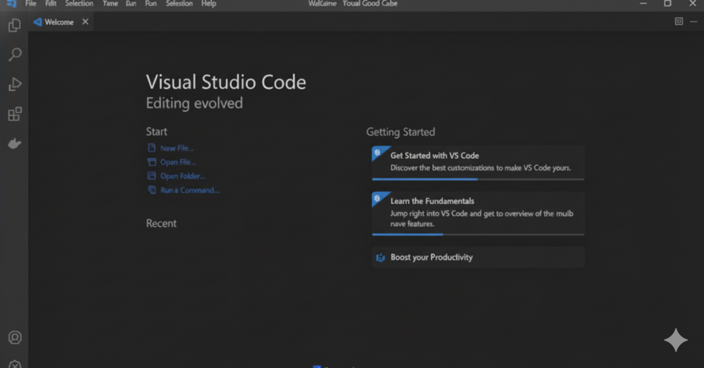

* 1. **PyCharm**

PyCharm is an integrated development environment (IDE) used in computer programming, specifically for the Python language. It is developed by the Czech company JetBrains (formerly known as IntelliJ). It provides code analysis, a graphical debugger, an integrated unit tester, integration with version control systems (CVSs), and supports web development with Django as well as data science with Anaconda. PyCharm is cross-platform, with Windows, macOS and Linux versions. The Community Edition is released index the Apache License, and there is also Professional Edition with extra features – released under a proprietary license

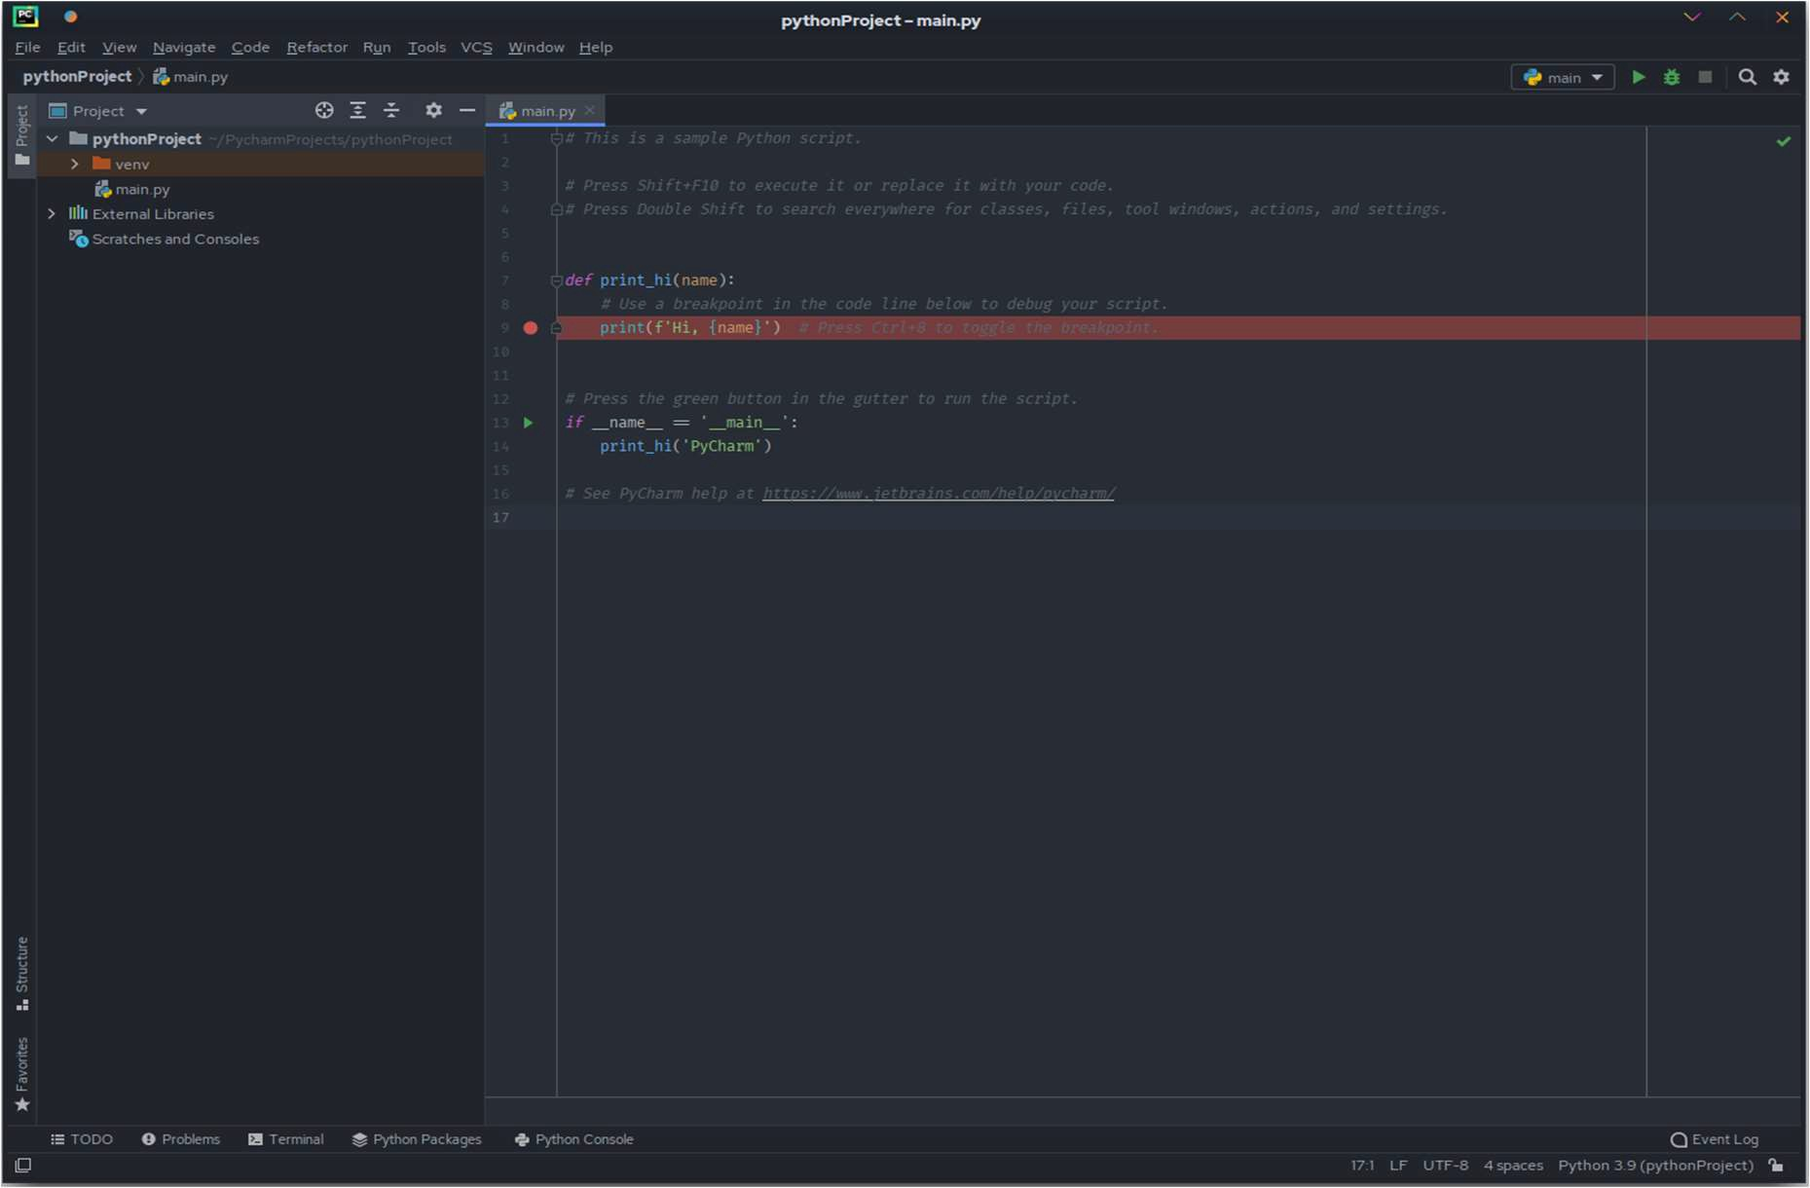

1. **REQUIREMENT ANALYSIS**

**3.1 Hardware Requirement: -**

* + - Computer/laptop
    - RAM: 8 GB or above

**3.2 Software Requirement: -**

1. operating system: Window 10/11
2. visual code
3. python
4. Django framework
   1. **Functional Requirements**

G.H. RAISONI College Portal system aims to improve the efficiency of college information management, and the main function is managing and maintaining information. The administrator and students are two major functional requirements in the system. The Administrator will be given more powers (enable/disable/ update) than other users. It will be ensured that the information entered is of the correct format. For example, name cannot contain numbers. In case if incorrect form of information is added, the users will be asked to fill the information again. Students use the system to query, get information and enter their information only.

* 1. **Non-Functional Requirements**
* **Performance Requirements:** The proposed system that we are going to develop will be used as the chief performance system for helping the organization in managing the whole database of the student studying in the organization and having message notifications. Therefore, it is expected that the database would perform functionally all the requirements that are specified.
* **Safety Requirements:** The database may get crashed at any certain time due to virus or operating system failure. Therefore, it is required to take the database backup.
* **Security Requirements:** We are going to develop a secured database. There are various categories of people namely Administrator, Student who will be viewing either all or some specific information. Depending upon the category of user the access rights are decided. It means if the user is an administrator, then he can be able to modify the data, append etc. All other users only have the rights to retrieve the information from database.
* **Database Management System (DBMS)** is a collection of programs that enables users to create and maintain a database. DBMS is a general – purpose software system that facilitates the process of defining, constructing, manipulating, and

sharing database among various users and applications. Defining a database involves the specifying the data types, structures, and constraints of the data to be stored in the database. The database definition or descriptive information is also stored in the database in the form of dictionary; it is called Meta data constructing the database is the process of storing the data on the storage medium that is controlled by DBMS.

1. **TECHNOLOGY USED**
   1. **Django Framework: -**

Django is a web application framework written in Python programming language. It is based on MVT (Model View Template) design pattern. The Django is very demanding due to its rapid development feature. It takes less time to build application after collecting client requirement. This framework uses a famous tag line: The web framework for perfectionists with deadlines. By using Django, we can build web applications in very less time. Django is designed in such a manner that it handles much of configure things automatically, so we can focus on application development only.

* 1. **HTML**

HTML is a hypertext mark-up language which is in reality a backbone of any website. Every website can’t be structured without the knowledge of html. If we make our web page only with the help of html, then we can’t add many of the effective features in a web page, for making a web page more effective we use various platforms such as CSS. So here we are using this language to make our web pages more effective as well as efficient. And to make our web pages dynamic we are using Java script.

* 1. **CSS**

CSS Stands for "Cascading Style Sheet." Cascading style sheets are used to format the layout of Web pages. They can be used to define text styles, table sizes, and other aspects of Web pages that previously could only be defined in a page’s HTML. The basic purpose of CSS is to separate the content of a web document (written in any markup language) from its presentation (that is written using Cascading Style Sheets). There are lots of benefits that one can extract through CSS like improved content accessibility, better flexibility and moreover, CSS gives a level of control over various presentation characteristics of the document. It also helps in reducing the complexity and helps in saving overall presentation time. CSS gives the option of selecting various style schemes and rules according to the requirements and it also allows the same HTML document to be presented in more than one varying style

1. **DATA FLOW DIAGRAM**
2. **Context 0th level diagram**

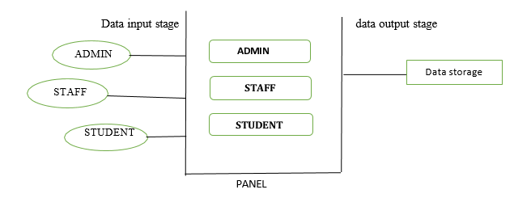

1. **Login Page**
2. **Admin detail data flow: -**
   1. 1st level detail data flow
3. Login page

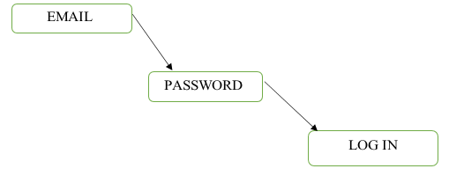

1. **Admin detail data flow: -**
   1. 1st level detail data flow

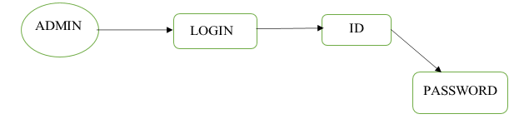

* 1. 2nd level detail data flow

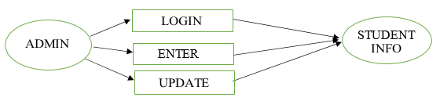

* 1. 3rd level detail data flow

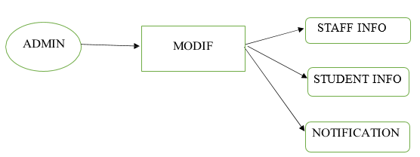

1. Staff detail data flow:
   1. 1st level detail data flow

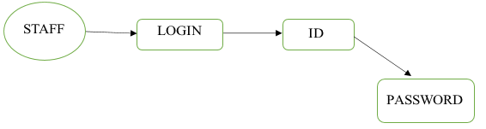

* 1. 2nd level detail data flow

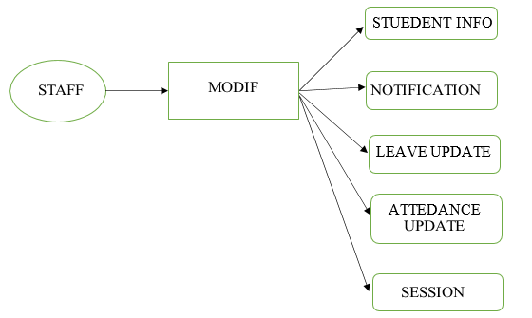

1. **Student detail data flow:**
   1. 1st detail data flow

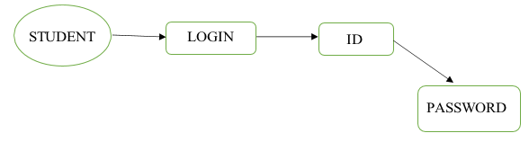

* 1. 2nd detail data flow

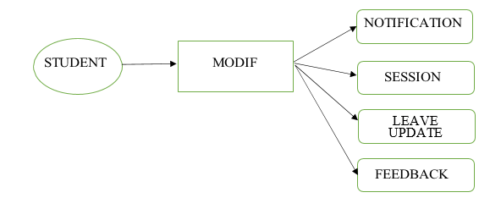

1. **RESULTS**

**LOGIN PAGE: -**

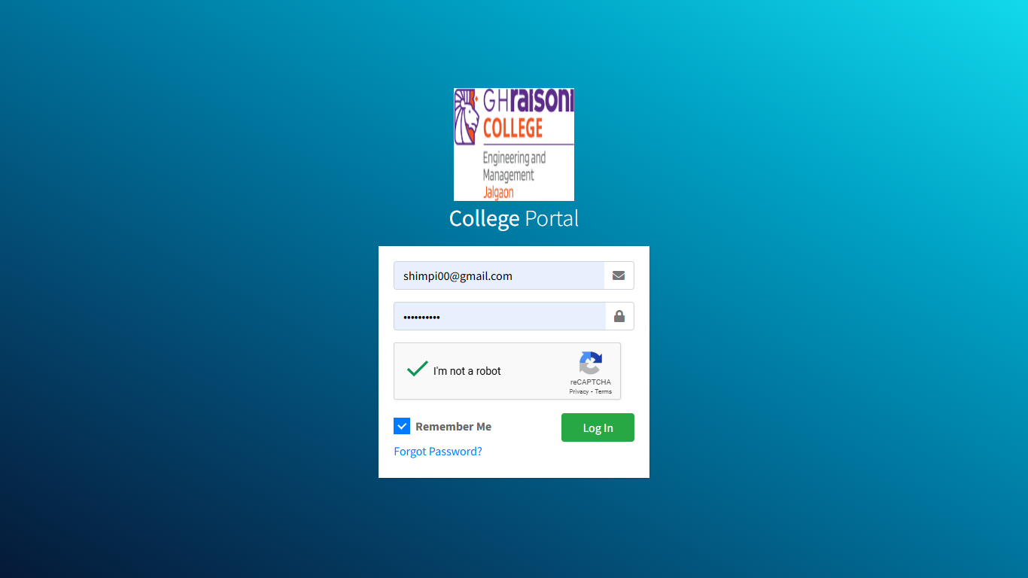

**6.1 Admin Panel: -**

HOME PAGE: -

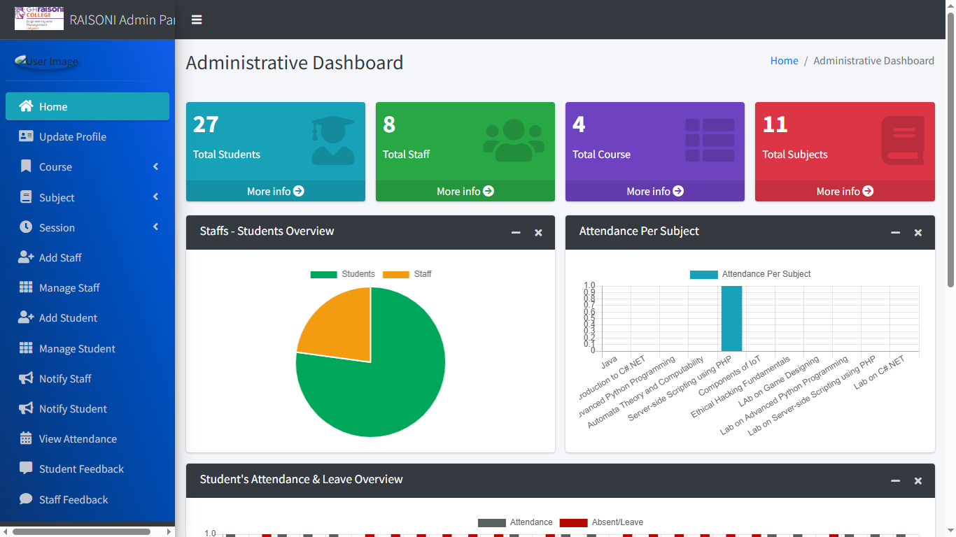

ADD THE SUBJECTS: -

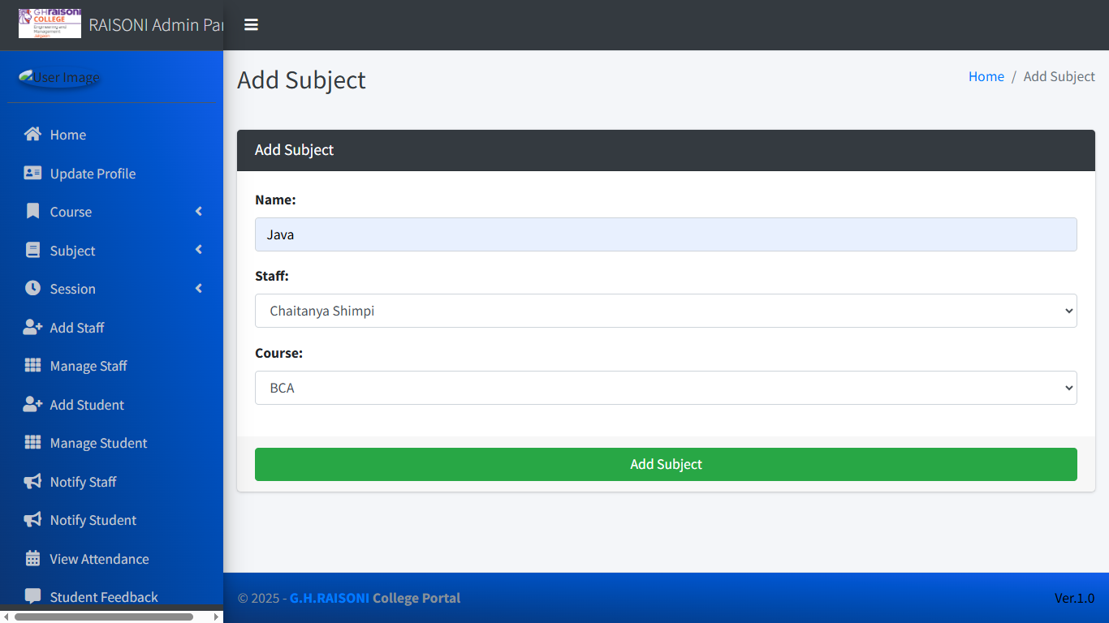

MANAGE SUBJECTS: -

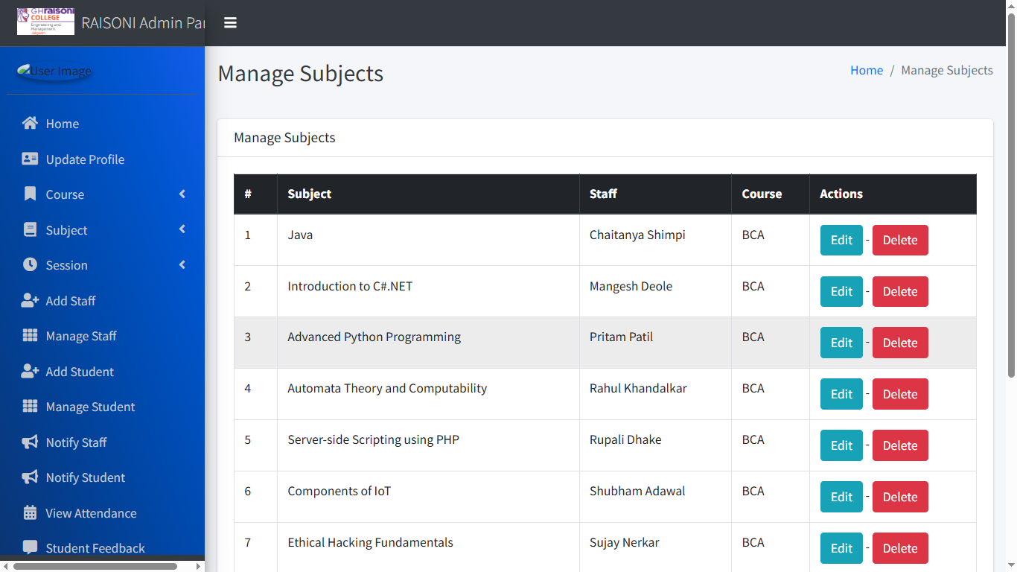

ADD SESSION: -

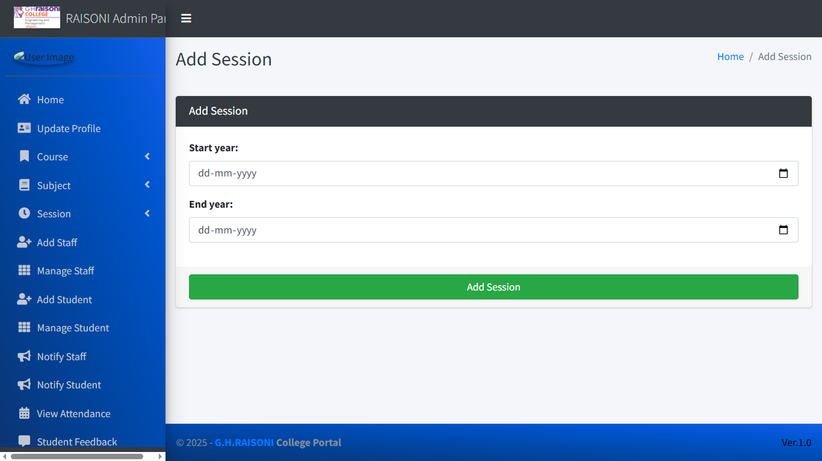

MANAGE SESSION: -

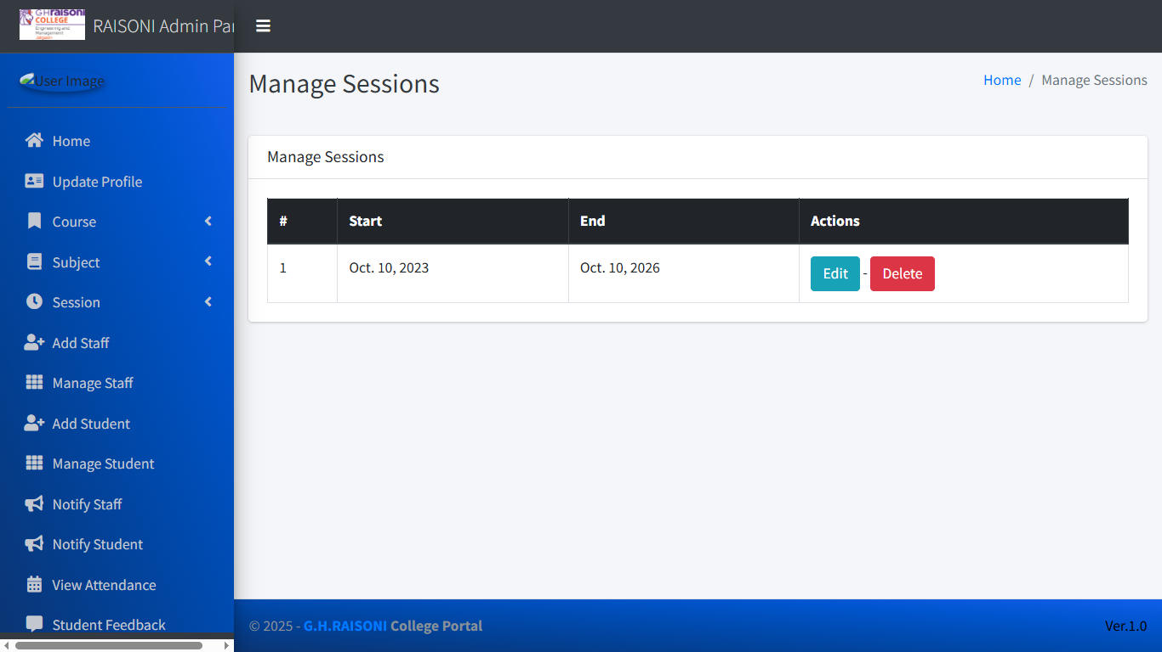

ADD THE STAFF: -

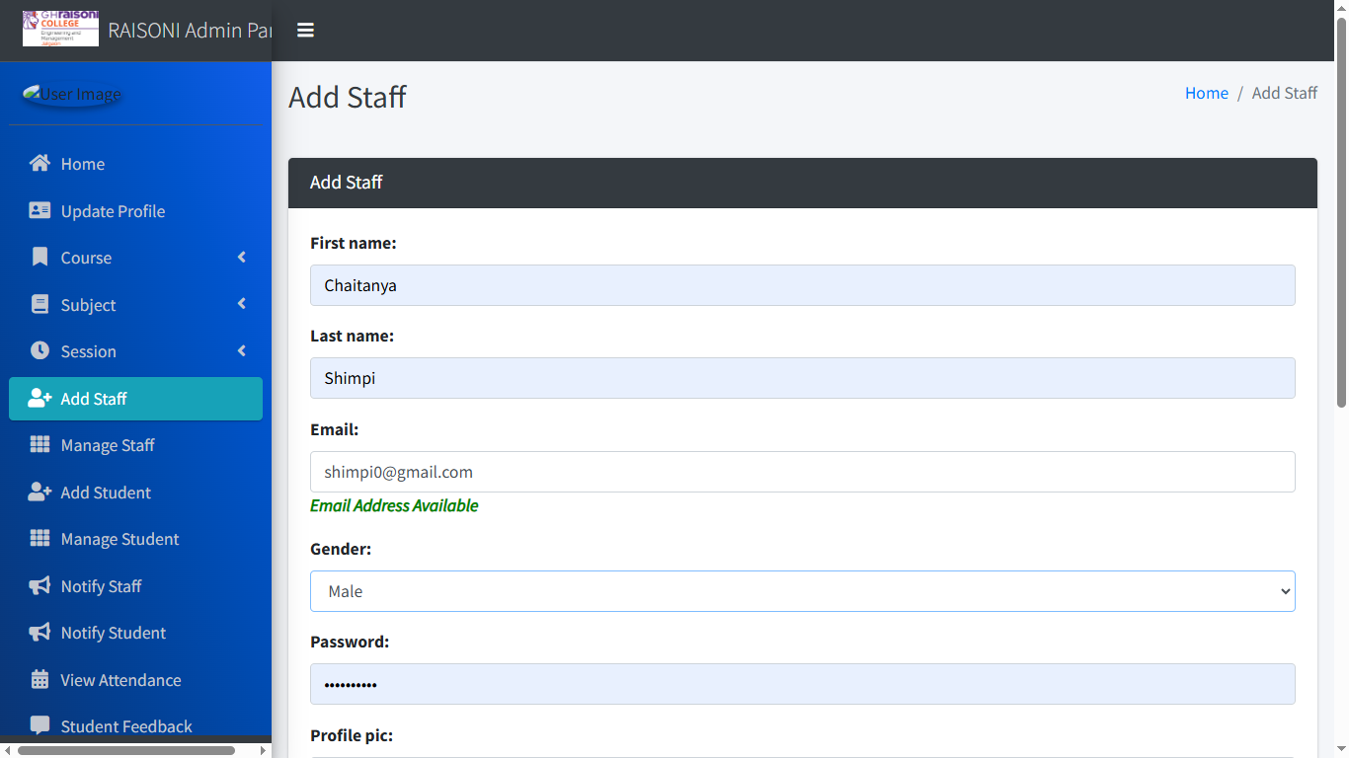

MANAGE STAFF: -

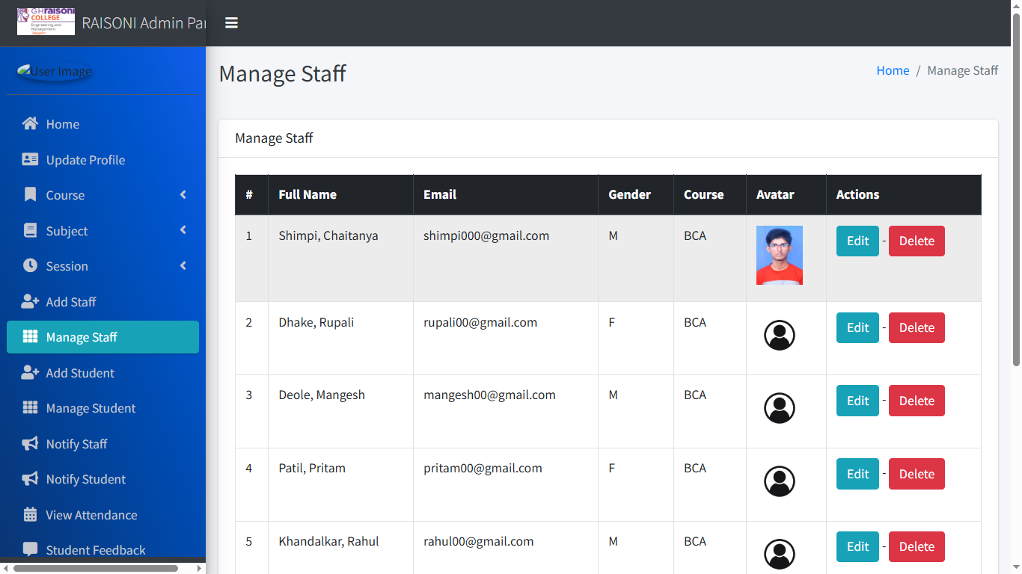

ADD THE STUDENTS: -

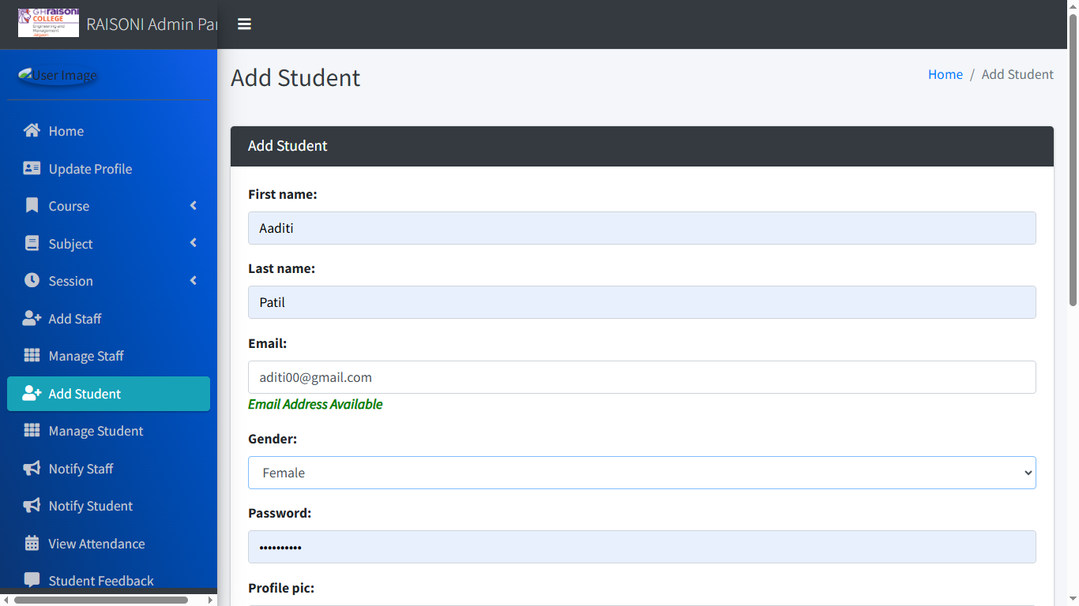

ATTENDANCE: -

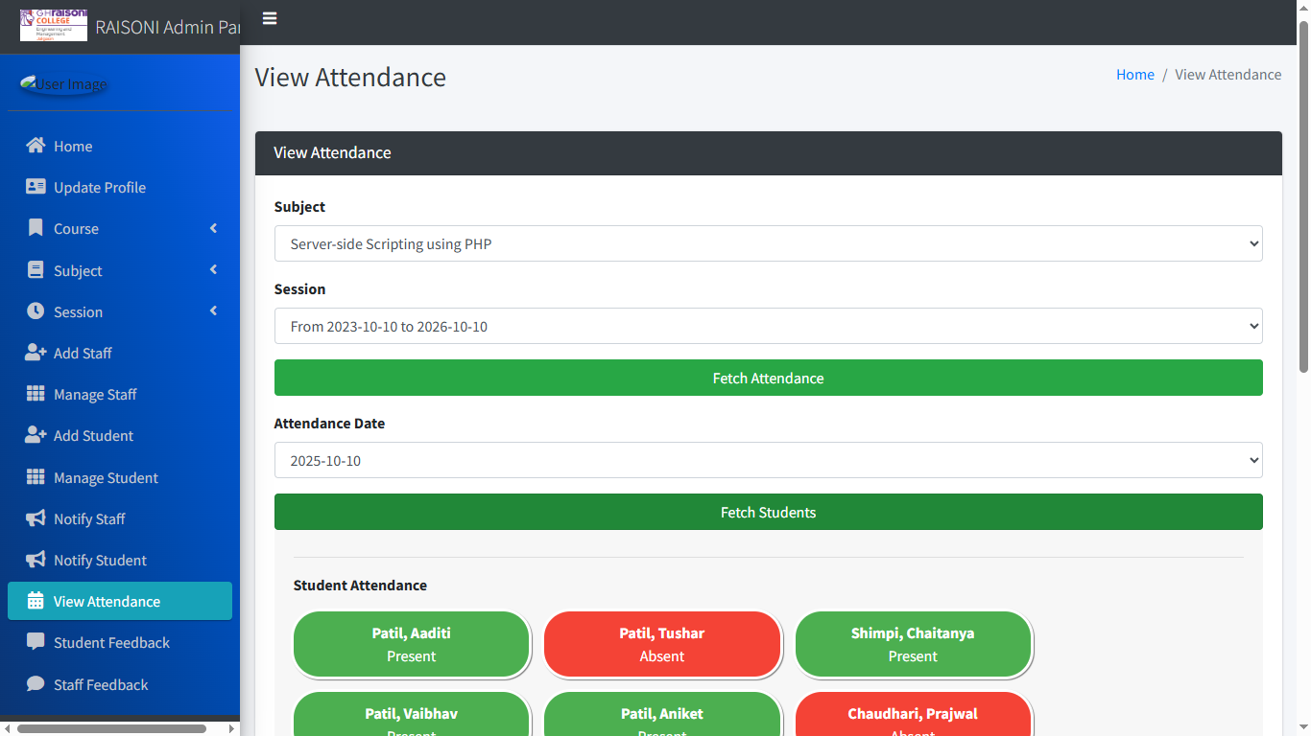

STUDENT FEEDBACK: -

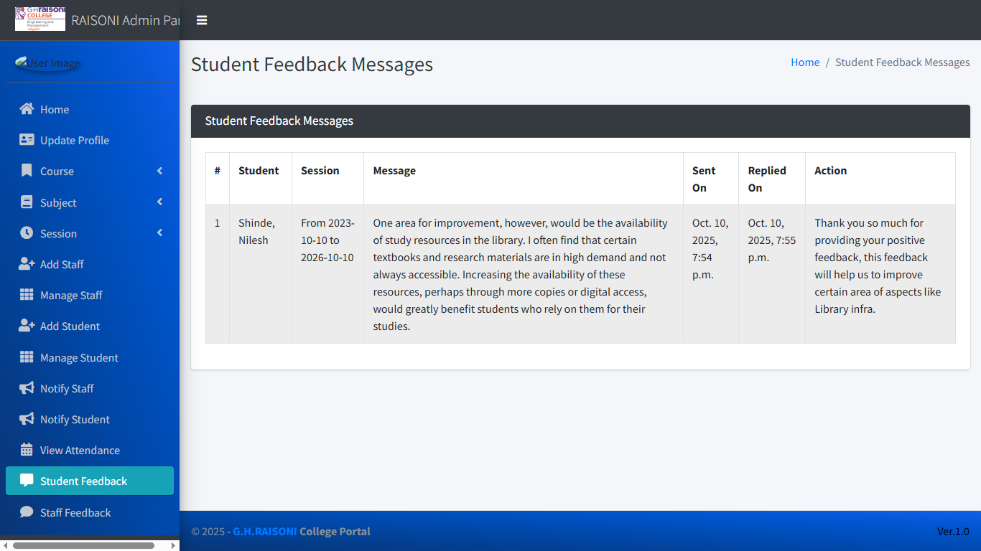

**6.2 Staff Panel Details: -**

HOME PAGE: -

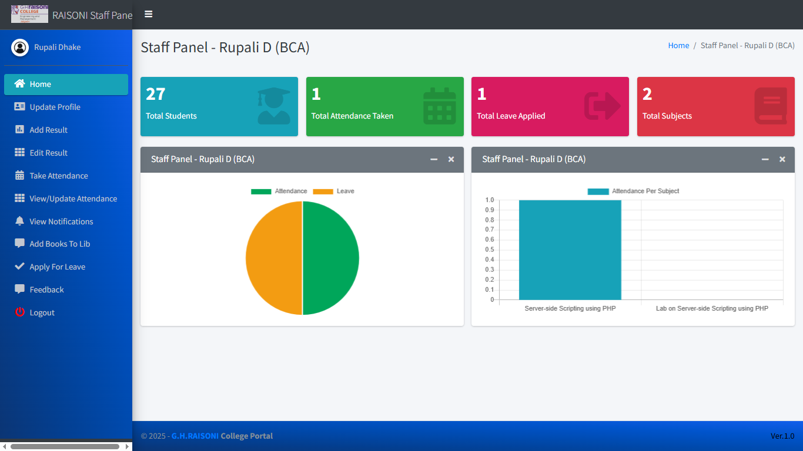

RESULT UPLOAD

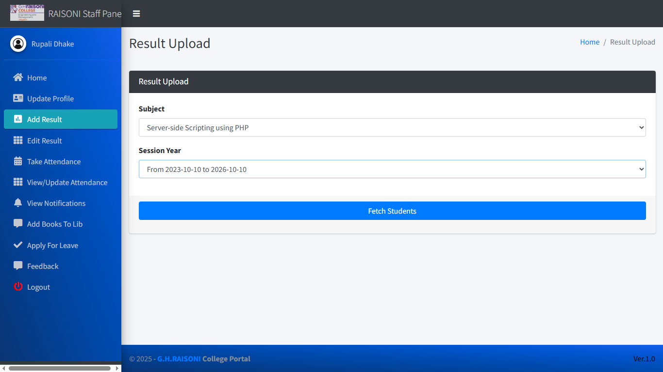

EDIT STUDENT’S RESULT: -

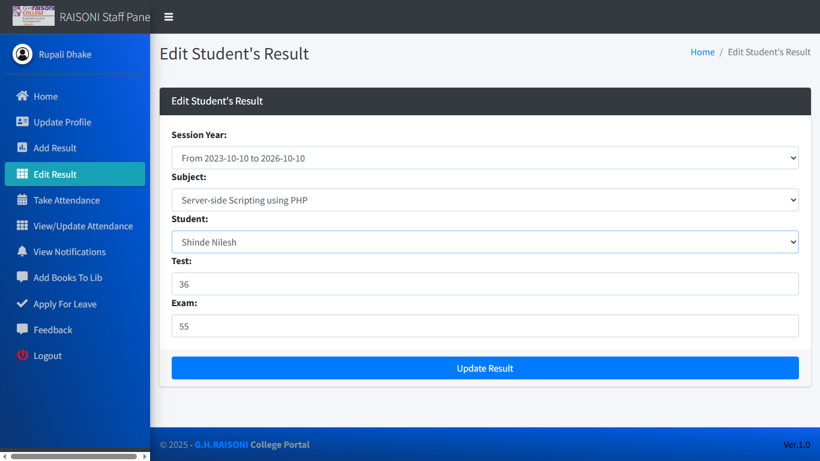

ATTENDANCE: -

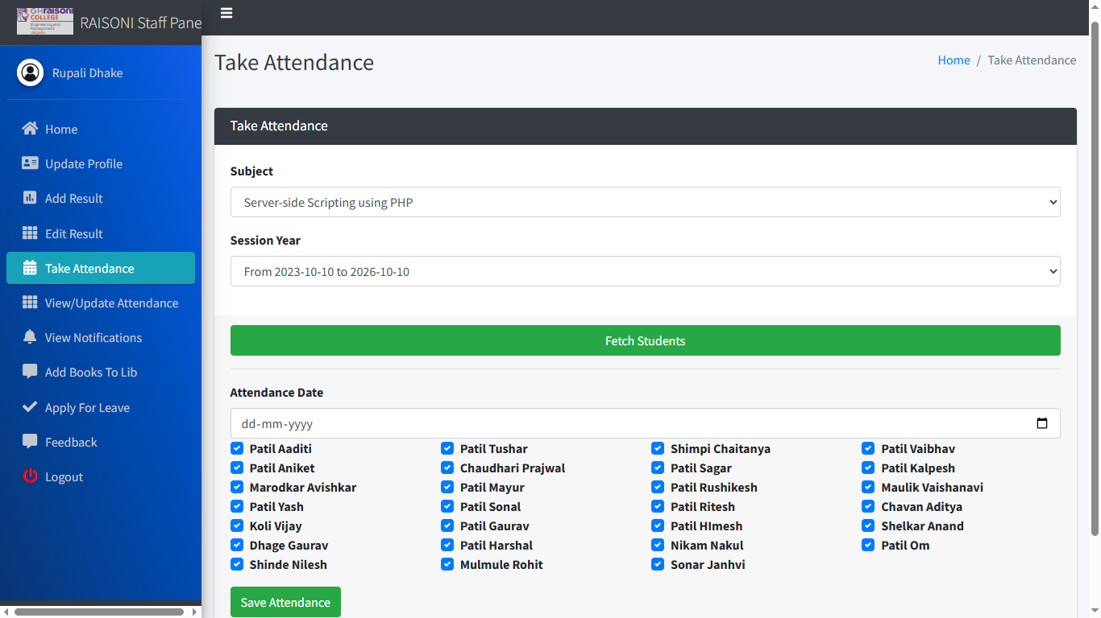

UPDATE ATTENDANCE: -

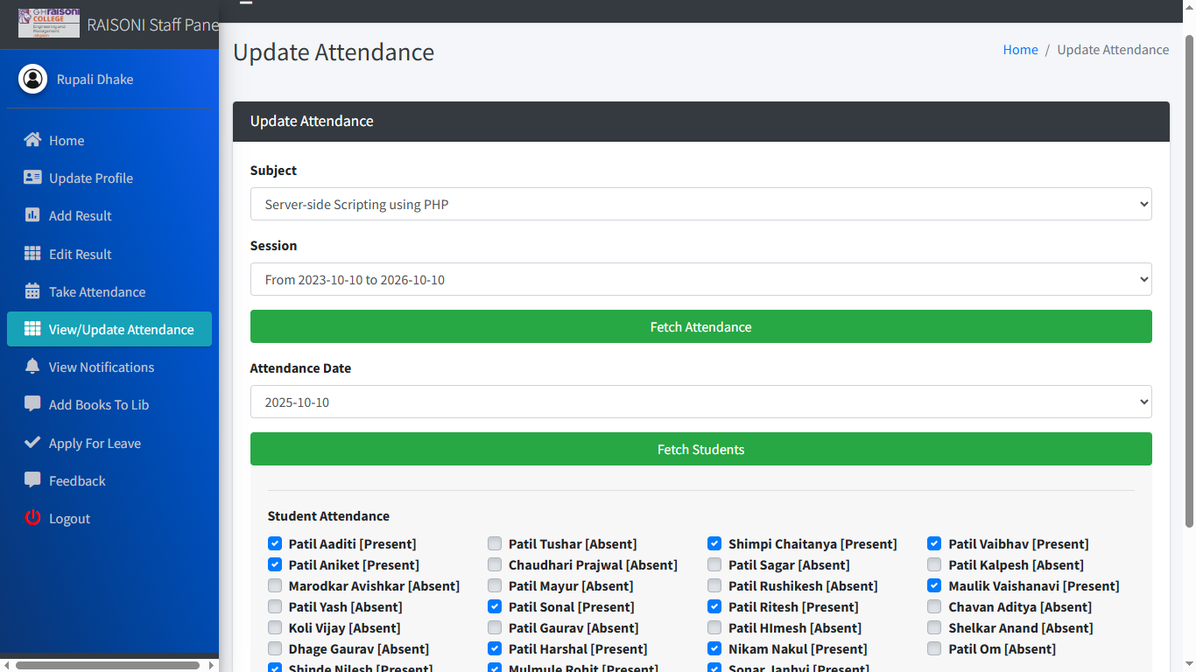

VIEW NOTIFICATION: -

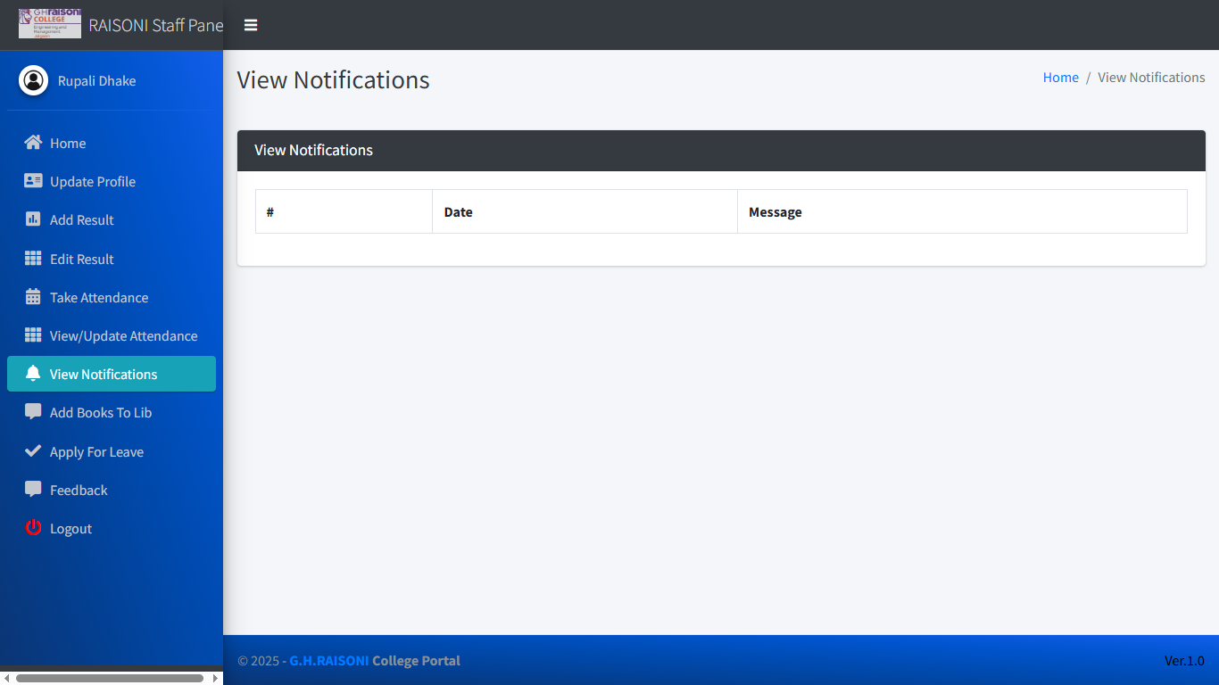

STAFF CAN ADD THEIR NOTES: -

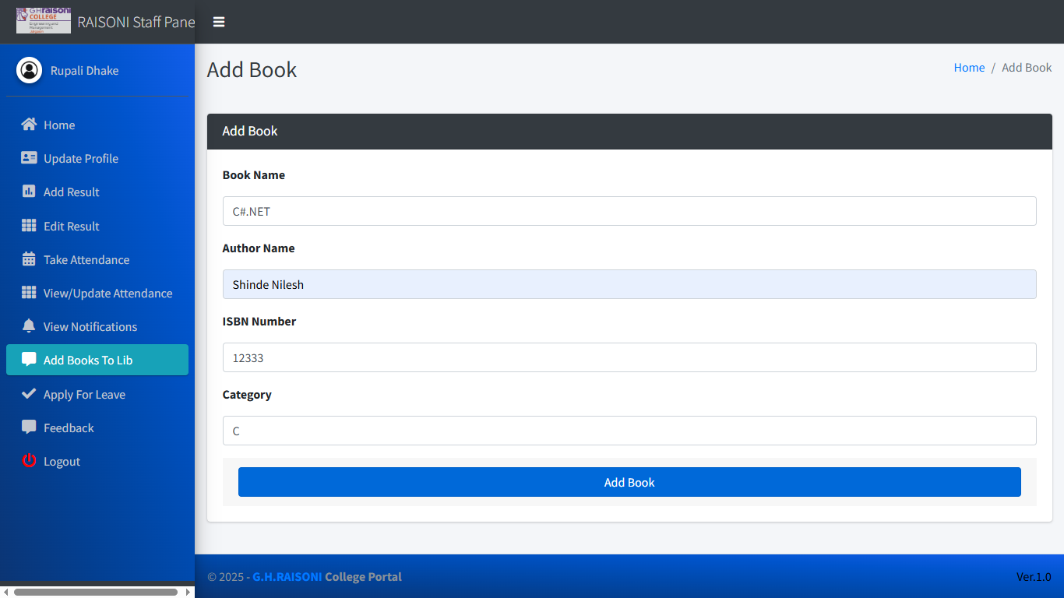

APPLY FOR LEAVE: -

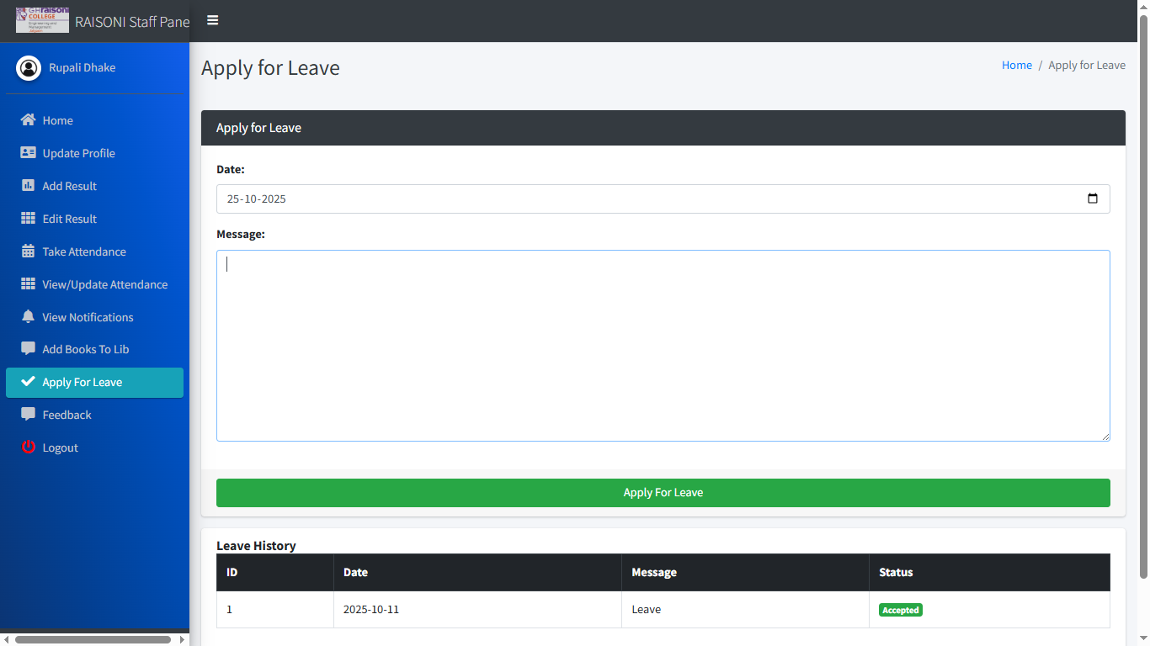

FEEDBACK: -

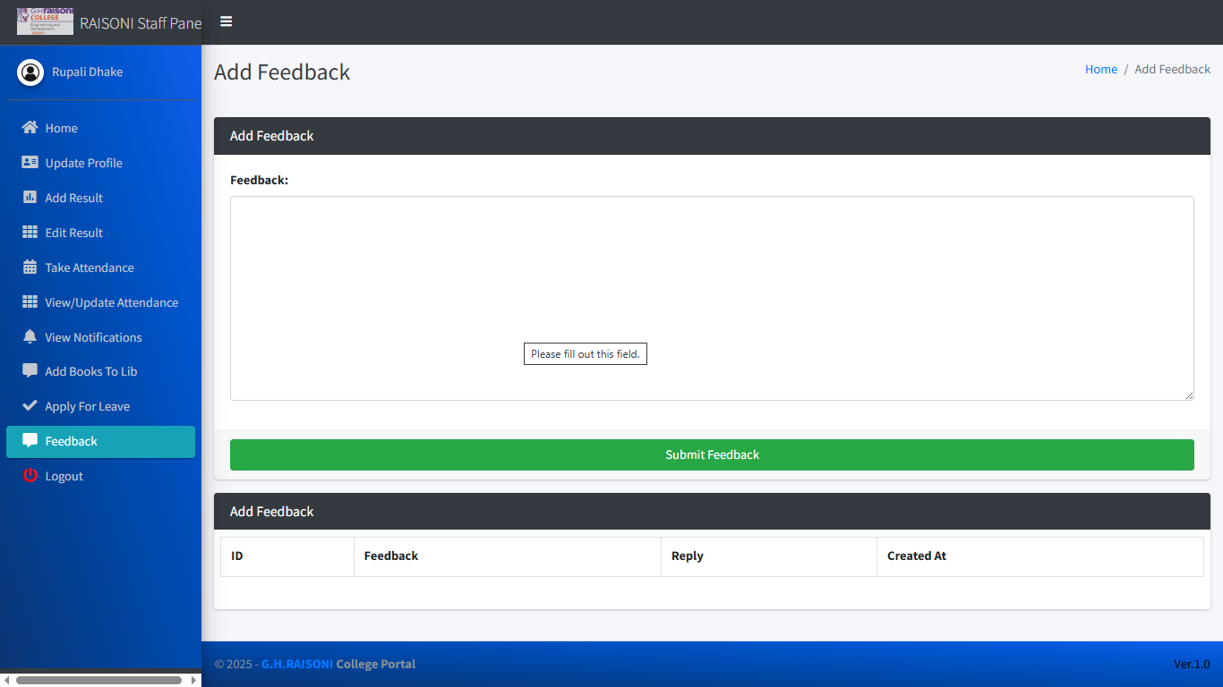

**6.3 Student Panel Details: -**

HOME PAGE: -

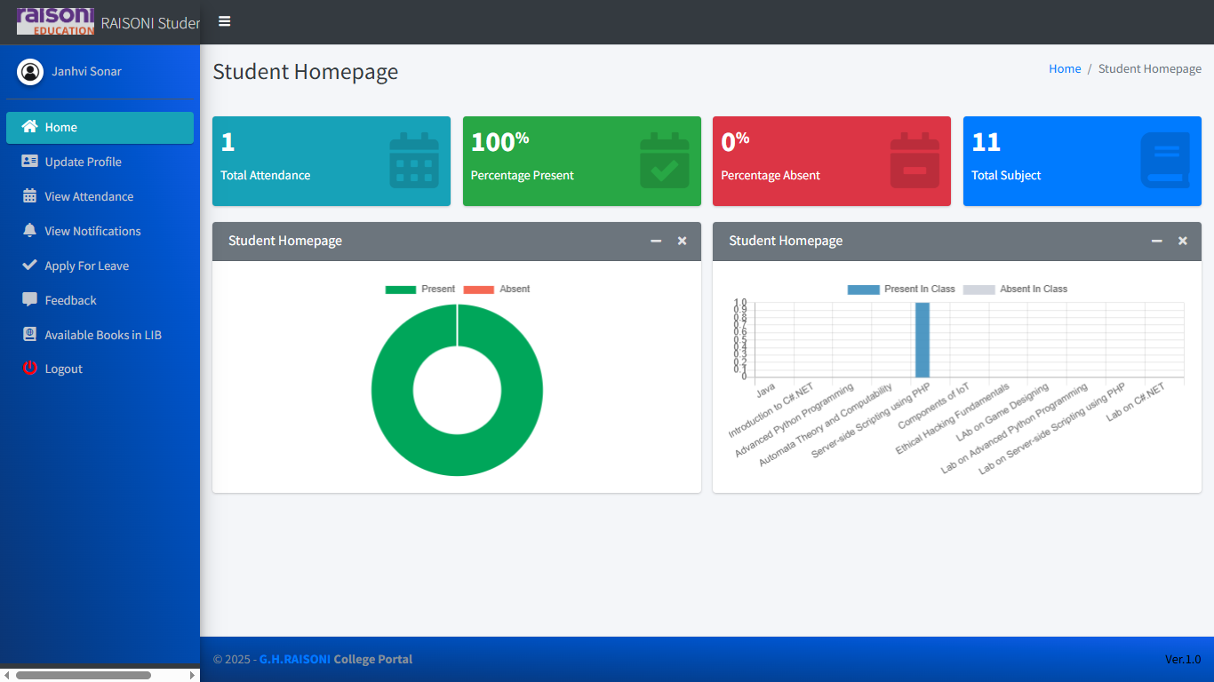

LIBRARY: -

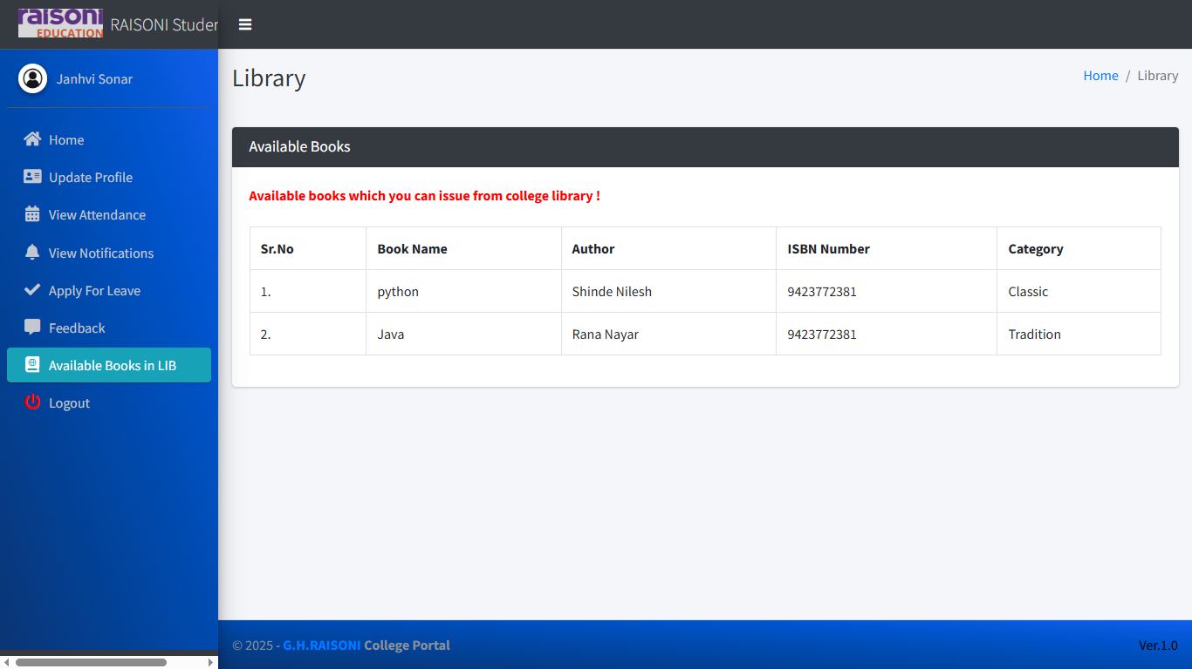

STUDENT FEEDBACK: -

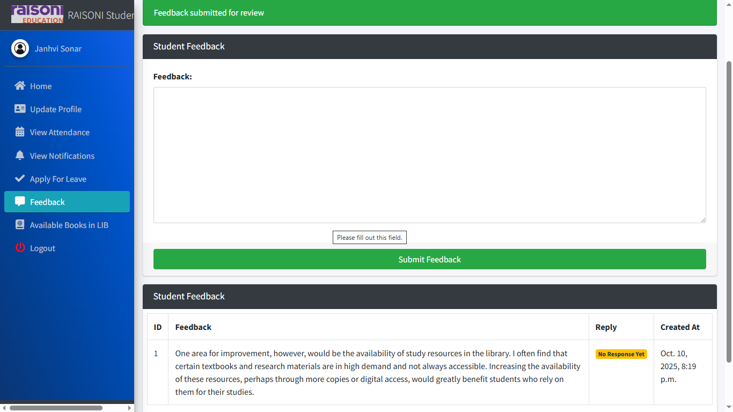

VIEW ATTENDENCE: -

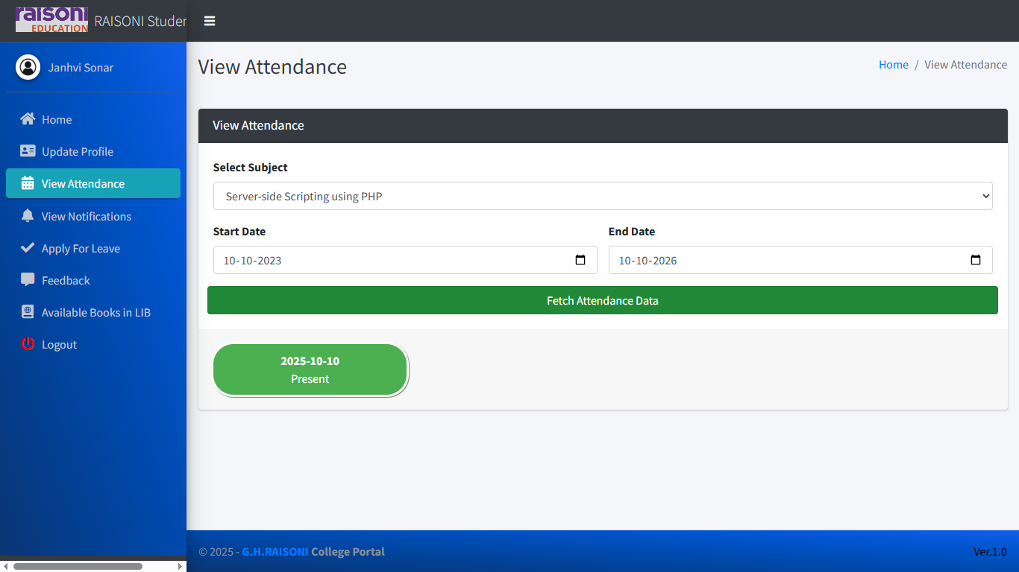

APPLY FOR LEAVE: -

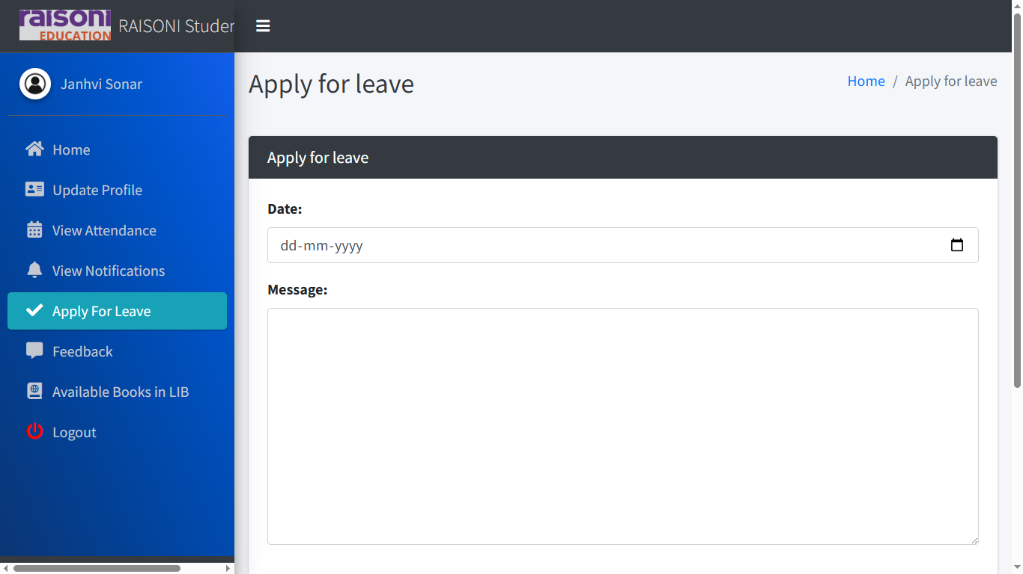

VIEW NOTIFICATIONS: -

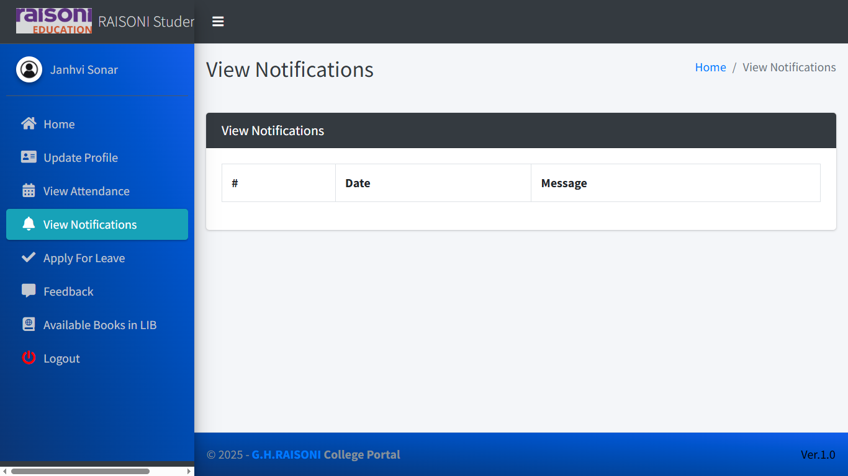

## **CONCLUSION**

This paper assists in automating the existing manual system. This is a paperless work. It can be monitored and controlled remotely. It reduces the man power required and provides accurate information. Malpractice can be reduced. All years together gathered information can be saved and can be accessed at any time. Therefore, the data stored in the repository helps in taking decision by management. So, it is better to have a Web Based system. All the stakeholders, faculty and management can get the required information without delay. This system is essential in the colleges and universities.

## **FUTURE SCOPE**

* This will make a student to update or analysis their problem
* This will help to add the new staffs and student’s and can check the correction of any mistake.
* This make the work essay and time shaving which is now most important part of the life.
* This will make easy to contact with student
* It will make education essay and control and education management best.

## **REFERENCES**

Software Engineering by Roger Pressman

[http://santronix.com/webdesigning/college%20website%2](http://santronix.com/webdesigning/college%20website%252) 0development%20solution.asp

Object –oriented Modelling and Design with UML by James Rumbaugh